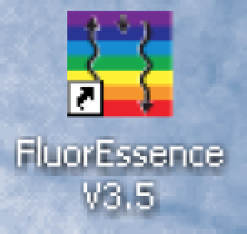
Operation of the Horiba Fluoromax4
Turn on the power switch (back right side of instrument.)
The data key must be in a USB port (behind computer) before starting the software. Double click the rainbow-colored FluorEssence icon on the desktop. Allow the software to make changes on the computer.

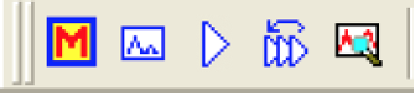
Click the M toolbar icon (experiment menu) or use menu/Collect/Experiment Setup.
The second icon is for modifying a previous experiment. Use for a series and fill in comments for each sample. The third icon is for repeating an experiment without modification. The fifth icon is for real time adjustment of experimental parameters.
(If the icons are all gray, use menu/Collect/System UI Reset.)

Click an available scan type, usually Spectra or Single Point.
Choose Emission or Excitation or Synchronous (both) and click Next.

Note the filename for the experiment and enter a descriptive title as a comment.
Set the monochromator wavelengths (Monos). For an Emission spectrum, choose the excitation wavelength, the emission scan range, and the slit widths. For an Excitation spectrum, choose the excitation scan range, the emission wavelength, and the slit widths. To minimize Rayleigh scatter, offset the start position by at least 15 nm from the excitation wavelength for a bandpass of 5 nm. Wider slit widths improve sensitivity but decrease resolution. If the signal exceeds 2 million cps, make the slits smaller.

Choose signals (Detectors). The R928P photomultiplier tube signal detector (S) is linear up to 2 million cps and should be enabled. First scanning and saving a solvent blank may be helpful. The silicon photodiode reference detector (R) monitors the lamp output. Using the ratio of the sample to the source, S1c/R1c, compensates for source fluctuations. The integration time or number of accumulations can be used to reduce signal to noise.

Insert sample in instrument and click the Run button in the lower right.
The data being recorded is shown in an intermediate display where the scan can be aborted, paused, or continued. At the end of the scan this window disappears and a new Origin window appears. Remember to save your project.

Double click a spectrum then click on the cursor tool. Use left and right arrows on the keyboard to move the cursor to the peak. The x-value is the peak wavelength.

Running an unknown sample
Obtain an emission spectrum. A good guess might be 300 nm excitation and 315-600 emission. If no peak is seen change the excitation wavelength. Note the emission peak location. Obtain an excitation spectrum using the just determined emission peak location and scanning excitation from 250 to the emission maximum minus 15 nm. Note the excitation peak location. Obtain an emission spectrum using the just determined excitation peak. Overlay the spectra and normalize the intensity.
Use menu/Analysis or click on
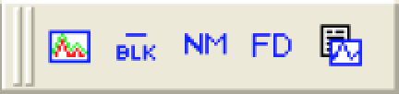
Overlay Normalize Save Settings
Blank View Settings

To overlay data in a window, click the overlay button. In the overlay window, click the browse button, , select the desired graphs, click >> to add the graphs to the list, click OK, choose which signal or reference, click OK, click OK.

To put more than one graph in a window, click the merge button, . In the graph manipulation window, click the browse button, , select the desired graphs, click >> to add the graphs to the list, click OK, choose which signal or reference, click OK, click OK.

To export data, open spectra, go to data tab, click on top of column(s), copy, and paste into Excel.

Maintenance

Check excitation wavelength calibration:
Run an excitation spectrum from 200 to 600 nm with 1 nm increment and 350 nm emission with both slit widths at 1 nm. Double click the graph and use the cursor tool to check that the tallest spike for the Xe lamp is at 467 nm in R1. To reset, choose previous experiment, then RTC, then Monos. Enter the actual observed position in the Excitation tab Position Control field. Click the Calibrate Excitation button. Enter 467 for the expected peak location and click OK. In the RTC window click Cancel.

Check emission wavelength calibration:
Run an emission spectrum of pure water from 365 to 450 nm with 1 nm increment and 350 nm excitation with both slit widths at 5 nm. Double click the graph and use the cursor tool to check that the water Raman peak is at 397 nm in S1. To reset, choose previous experiment, then RTC, then Monos. Enter the actual observed position in the Emission tab Position Control field. Click the Calibrate Excitation button. Enter 397 for the expected peak location and click OK. In the RTC window click Cancel.

Xenon lamp
After 1200–1500 h of use, the lamp output decreases significantly, indicating that the lamp should be replaced. A new lamp produces a peak intensity of 400,000 cps for a water-Raman scan; when the current lamp’s output drops below 100,000 cps, replace it. Each time the lamp is turned on counts as one full hour of use; leave the lamp on during brief periods of inactivity.

